Nama : Raden Sadiah Maharani

NIM : 2107126368

Basis Data Lanjut

Tugas Section 11

1. Create a list of all tables whose first two characters in the name of the table is JO. The tables must be owned by the current Oracle User.

→ SELECT table_name

FROM user_tables

WHERE table_name LIKE 'JO%';

Result :

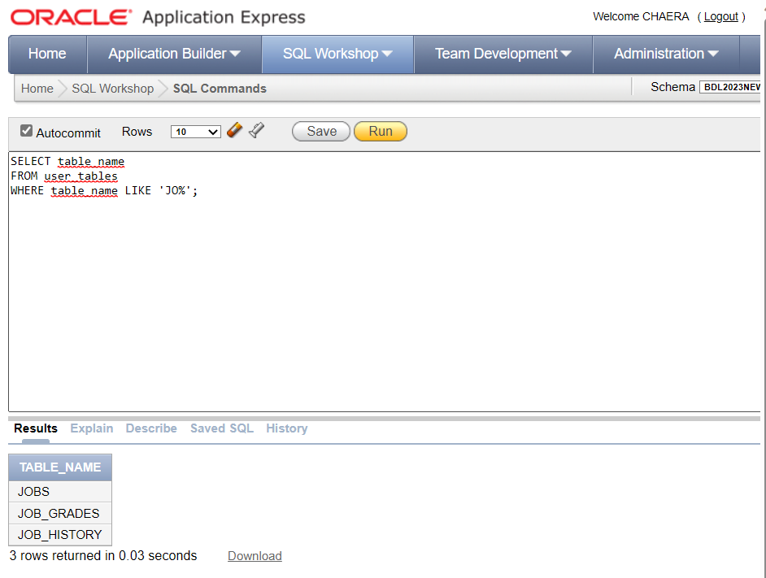

1. Create a list that includes the first initial of every employee's first name, a space, and the last name of the employee.

→ SELECT SUBSTR(first_name, 1, 1)||' '||last_name AS "Employees Names"

FROM employees;

Result :

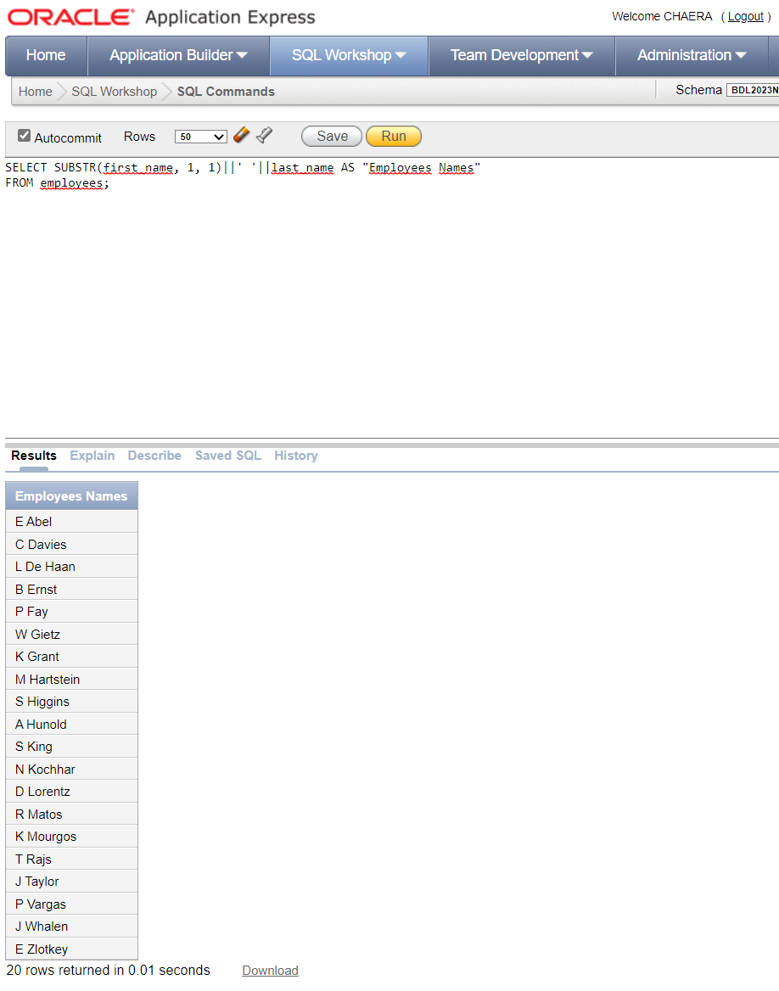

1. Create a list of every employee's first name concatenated to a space and the employee's last name, and the email of all employees where the email address contains the string 'IN'.

→ SELECT first_name||''||last_name

AS "Employees Name",

email AS "Email"

FROM employees

WHERE email LIKE '%IN%';

Result :



1. Create a list of 'smallest' last name and the 'highest' last name from the employees table.

→ SELECT MIN(last_name) AS "First Last Name",

MAX(last_name) AS "Last Last Name"

FROM employees;

Result :



1. Create a list of weekly salaries from the employees table where the weekly salary is between 700 and 3000. The salaries should be formatted to include a $- sign and have two decimal points like: $9999.99.

→ SELECT TO_CHAR((salary/4.33), '$9999.99')

AS "Weekly Salary"

FROM employees

WHERE (salary/4.33) BETWEEN 700 AND 3000;

Result :

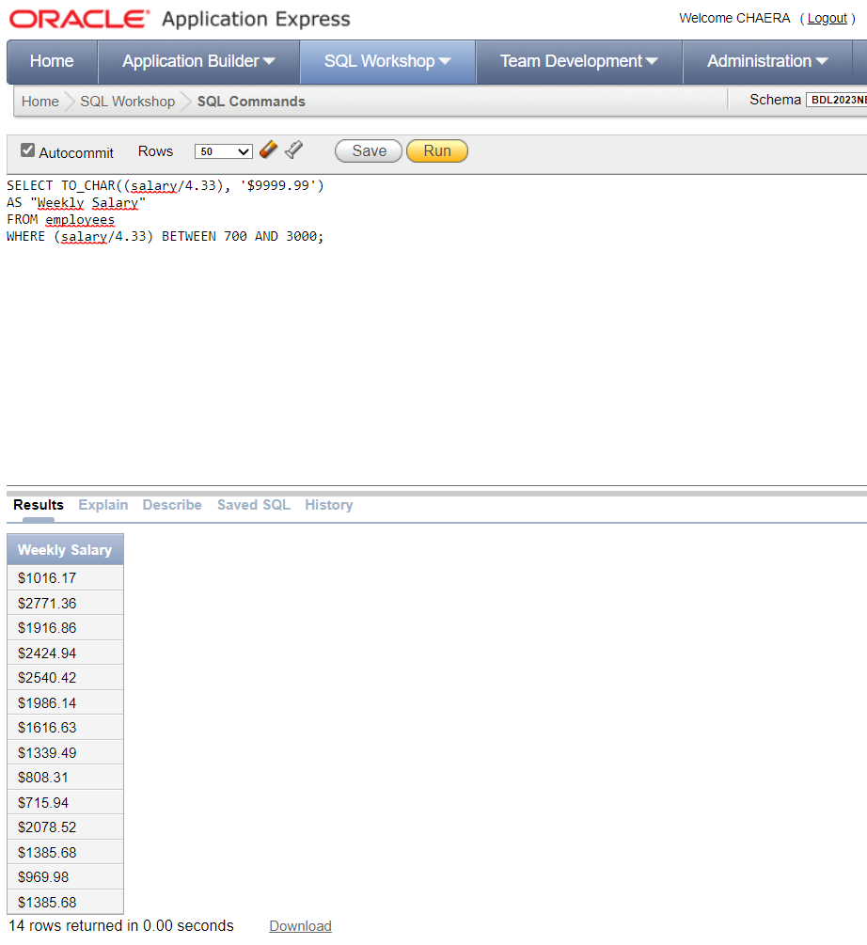

1. Create a list of every employee and his related job title sorted by job_title.

→ SELECT SUBSTR(first_name,1,1)||' '||last_name as "Emloyee Name", job_title as "Job"

FROM employees e

JOIN jobs j ON e.job_id = j.job_id

ORDER BY j.job_title;

Result :

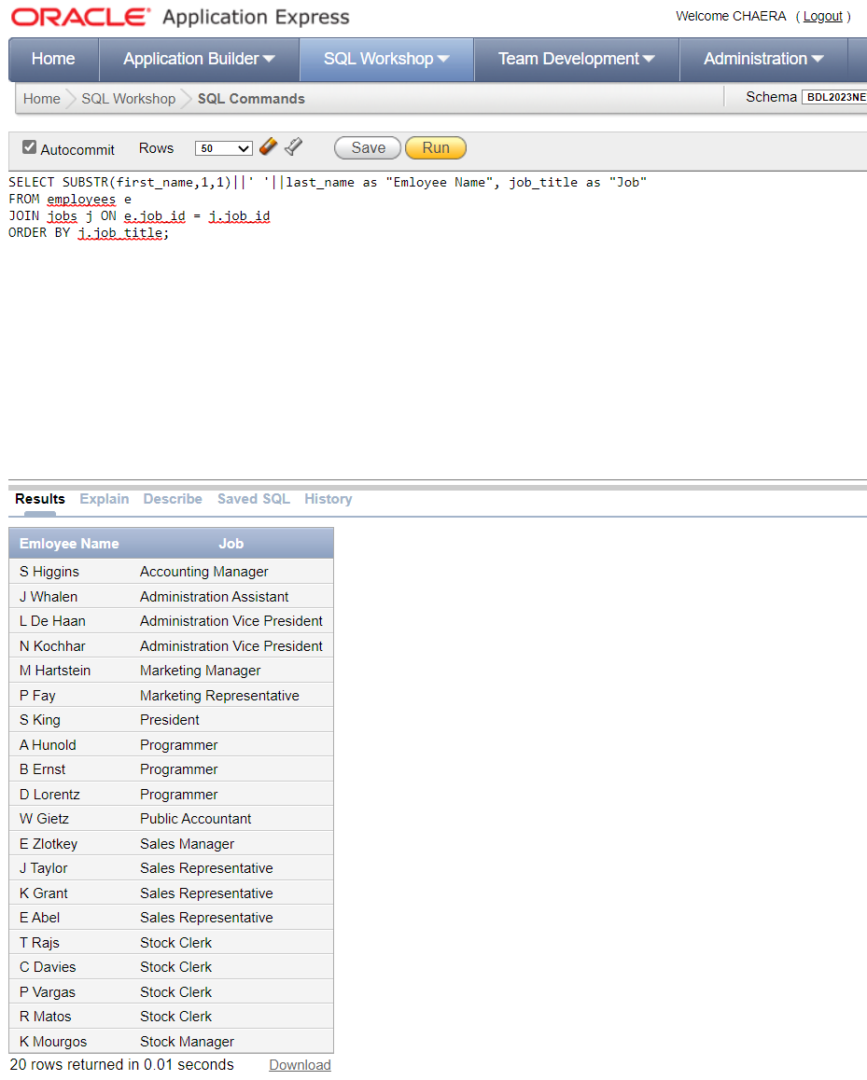

1. Create a list of every employee’s job, the salary ranges within the job, and the employee's salary. List the lowest and highest salary range within each job with a dash to separate the salaries like this: 100 – 200.

→ SELECT SUBSTR(first_name,1,1)||' '||last_name as "Emloyee Name",

job_title as "Job",

MIN(j.min_salary) || ' - ' || MAX(j.max_salary) as "Salary Range",

e.salary as "Employee's Salary"

FROM employees e

JOIN jobs j ON e.job_id = j.job_id

GROUP BY e.first_name, e.last_name, j.job_title, e.salary

ORDER BY j.job_title;

Result :

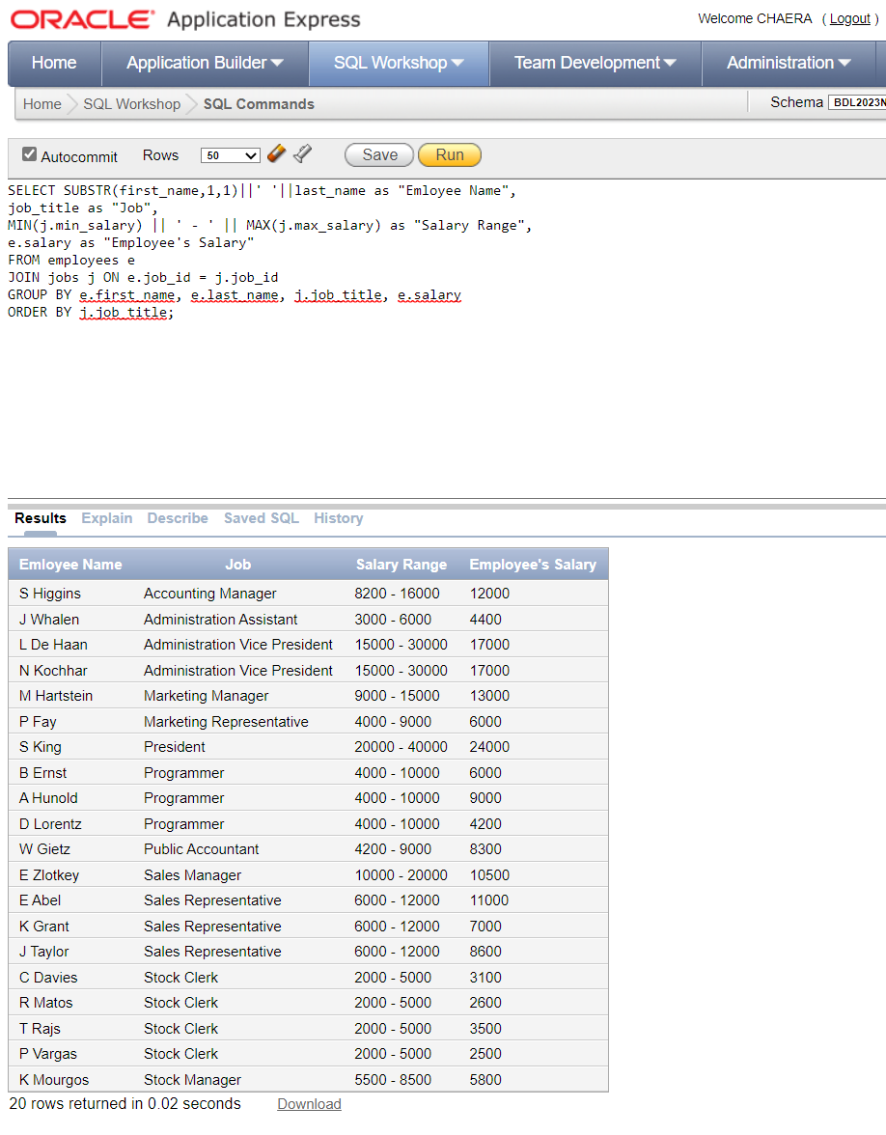

1. Using an ANSII join method, create a list of every employee's first initial and last name, and department name. Make sure the tables are joined on all of the foreign keys declared between the two tables.

→ SELECT SUBSTR(first_name, 1, 1) || ' ' || last_name as "Employee Name", d.department_name as "Department Name"

FROM employees e

JOIN departments d ON e.department_id = d.department_id

JOIN locations l ON d.location_id = l.location_id

JOIN countries c ON l.country_id = c.country_id

JOIN regions r ON c.region_id = r.region_id;

Result :

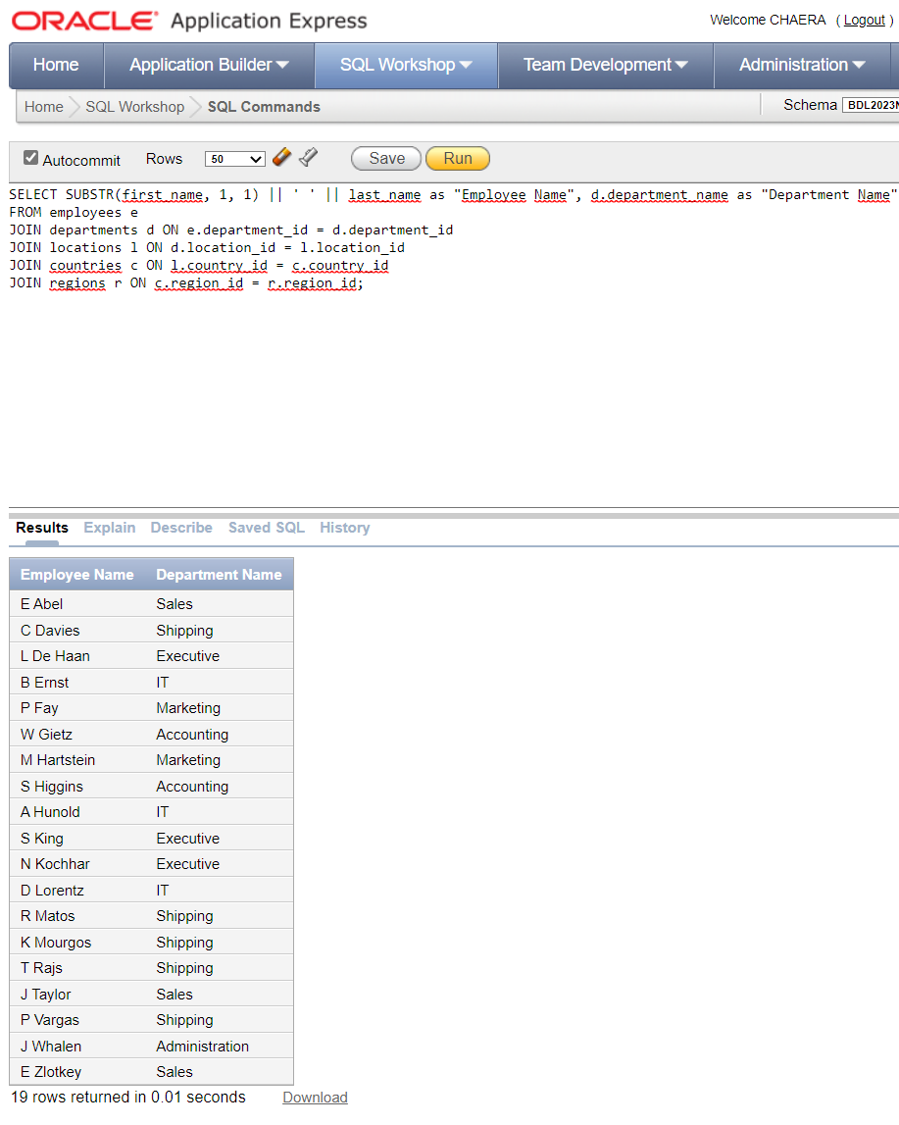

1. Change the previous listing to join only on the department_id column.

→ SELECT SUBSTR(e.first_name, 1, 1) || ' ' || e.last_name as "Employee Name",

d.department_name as "Department Name"

FROM employees e

JOIN departments d ON e.department_id = d.department_id;

Result :

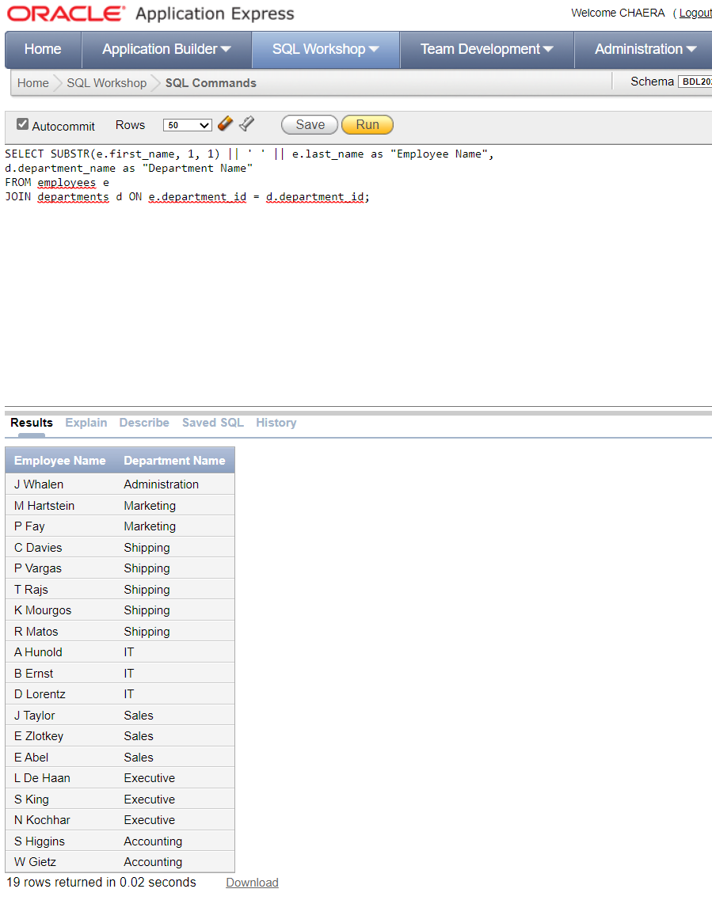

1. Create a list of every employee's last name, and the word nobody or somebody depending on whether or not the employee has a manager. Use the Oracle DECODE function to create the list.

→ SELECT DECODE(manager_id, NULL, 'Nobody', 'Somebody') as "Work For", last_name as "Last Name"

FROM employees;

Result :

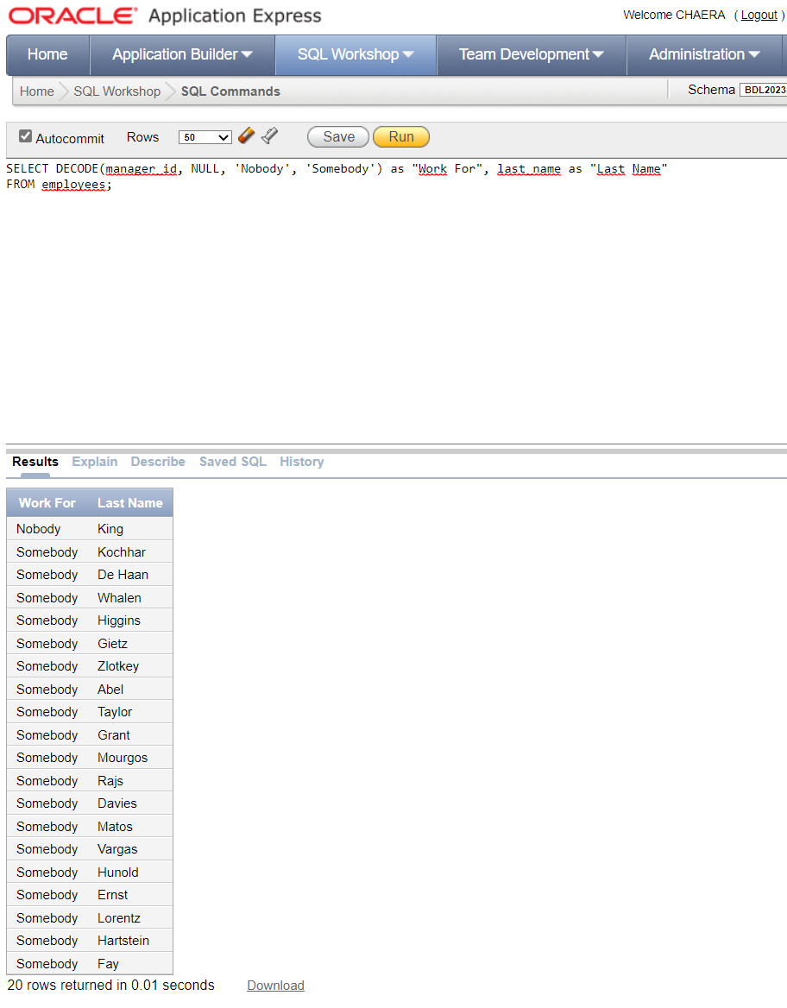

1. Create a list of every employee's first initial and last name, salary, and a yes or no to show whether or not an employee makes a commission.

Fix this query to produce the result.

SELECT SUBSTR(first_name,1 1)||' '|last_name,

"Employee Name", salary "Salary",

DEC(commission_pct NULL, 'No', 'Yes')'Commission'

FROM employees;

→ SELECT SUBSTR(first_name, 1, 1) || ' ' || last_name AS "Employee Name",

salary AS "Salary",

DECODE(commission_pct, NULL, 'No', 'Yes') AS "Commission"

FROM employees;

Result :

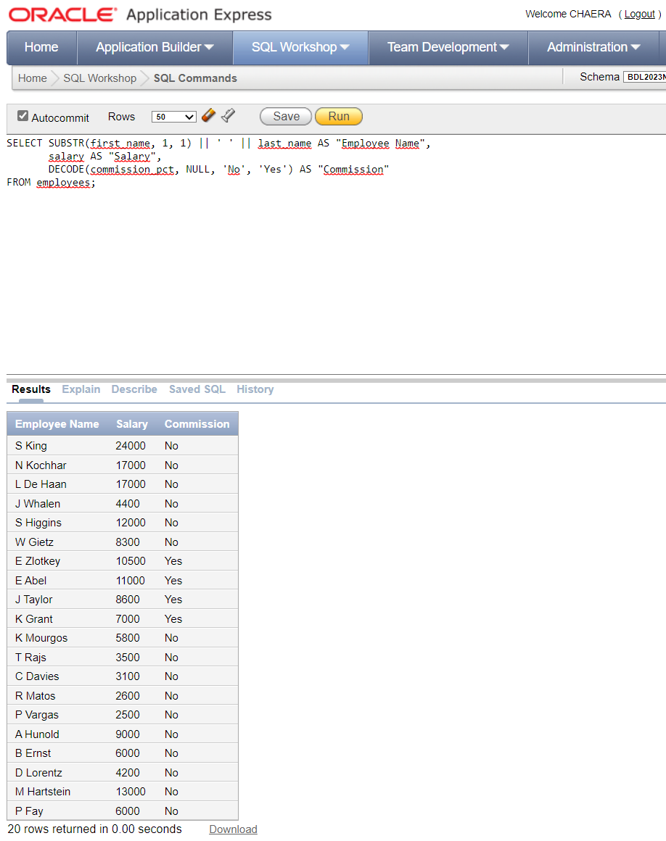

1. Create a list of every employee's last name, department name, city, and state_province.

Include departments without employees.

An outer join is required.

→ SELECT last_name,

department_name,

city,

state_province

FROM departments d

LEFT OUTER JOIN employees e ON d.department_id = e.department_id

LEFT OUTER JOIN locations l ON d.location_id = l.location_id

ORDER BY e.last_name;

Result :

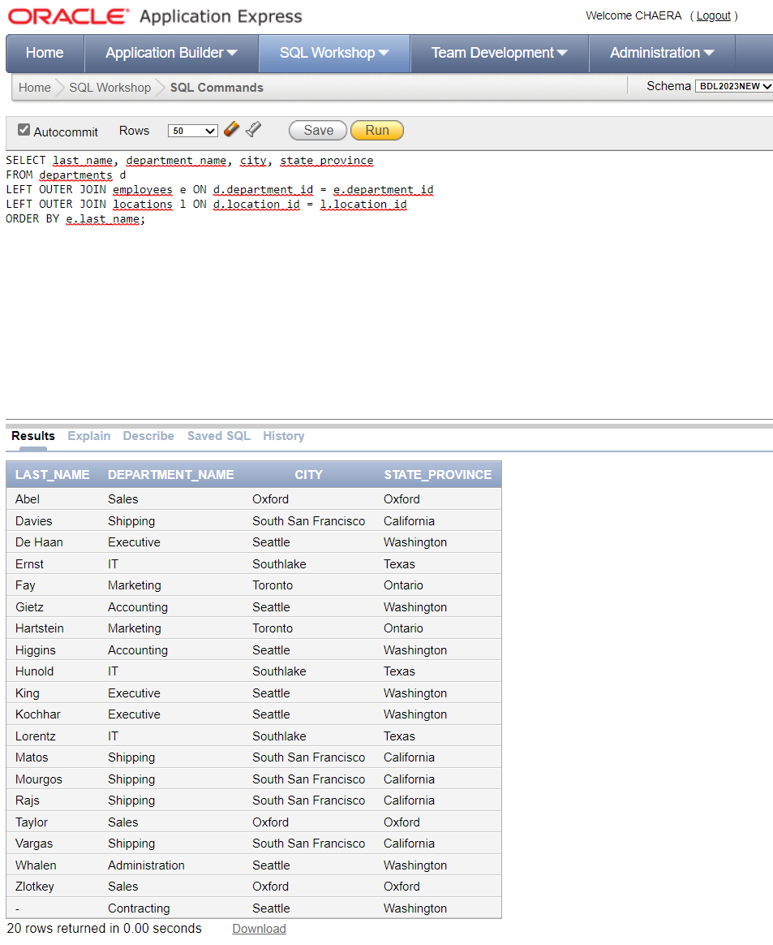

1. Create a list of every employee's first and last names, and the first occurrence of: commission_pct, manager_id, or -1.

If an employee gets commission, display the commission_pct column; if no commission, then display his manager_id; if he has neither commission nor manager, then the number -1.

→ SELECT first_name as "First Name",

last_name as "Last Name",

COALESCE(commission_pct, manager_id, -1)

as "Which Function?"

FROM employees;

Result :

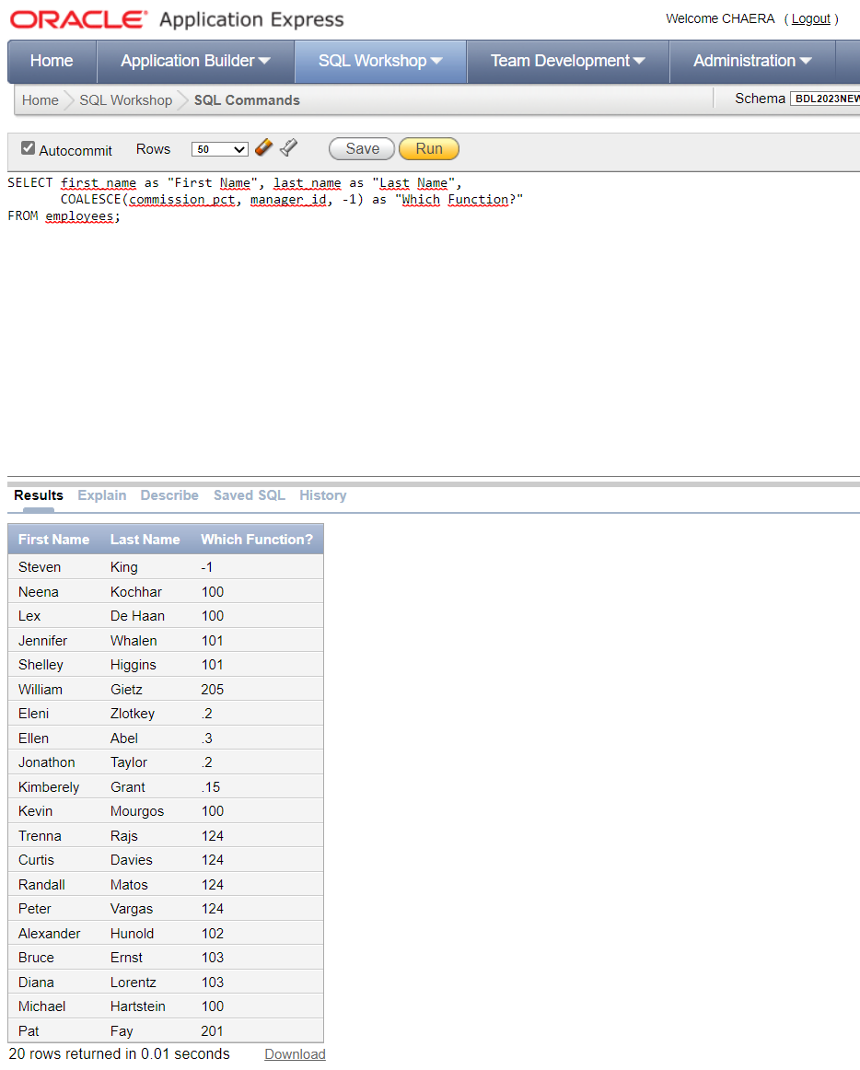

1. Create a list of every employee's last name, salary, and job_grade for all employees working in departments with a department_id greater than 50.

→ SELECT e.last_name, e.salary, jg.grade_level

FROM employees e

JOIN departments d ON e.department_id = d.department_id

JOIN job_grades jg ON e.salary BETWEEN jg.lowest_sal AND jg.highest_sal

WHERE d.department_id > 50

ORDER BY jg.grade_level;

Result :

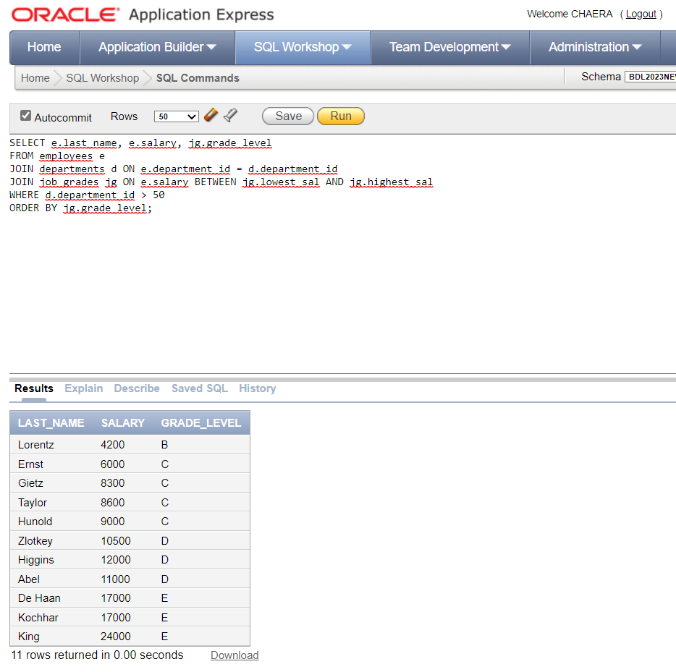

1. Produce a list of every employee's last name and department name. Include both employees without departments, and departments without employees.

→ SELECT last_name, department_name

FROM employees e

FULL OUTER JOIN departments d ON e.department_id = d.department_id

ORDER BY last_name;

Result :

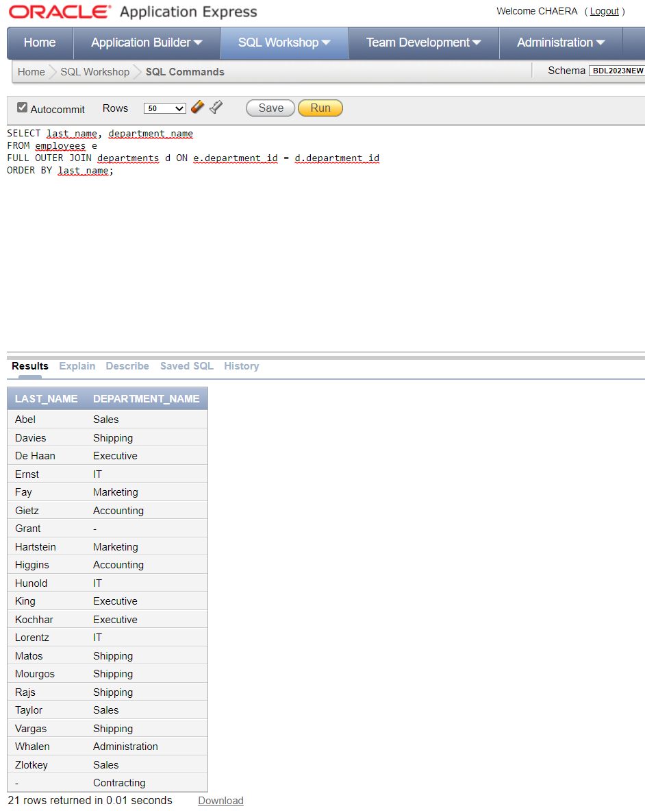

1. Create a treewalking list of every employee's last name, his manager’s last name, and his position in the company. The top level manager has position 1, this manager's subordinates position 2, their subordinates position 3, and so on.

Start the listing with employee number 100.

→ SELECT LEVEL as position, e.last_name as employee_name, m.last_name as manager_name

FROM employees e

LEFT JOIN employees m ON e.manager_id = m.employee_id

WHERE LEVEL = 1 OR LEVEL >= 2

START WITH e.employee_id = 100

CONNECT BY PRIOR e.employee_id = e.manager_id

ORDER BY position, employee_name;

Result :

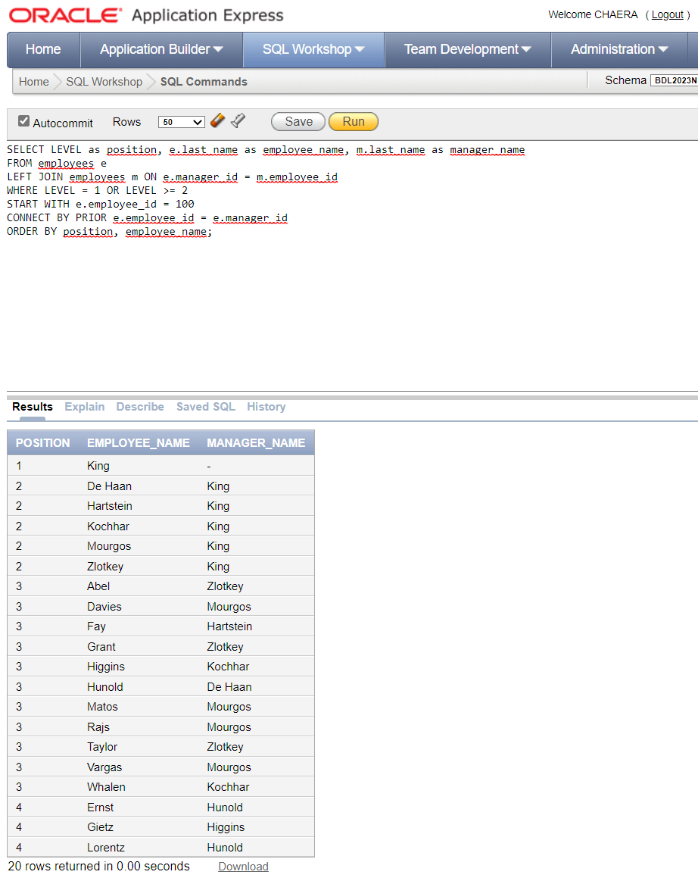

1. Produce a list of the earliest hire date, the latest hire date, and the number of employees from the employees table.

→ SELECT MIN(hire_date) as "Lowest", MAX(hire_date) as "Highest", COUNT(*) as "No of Employees"

FROM employees;

Result :

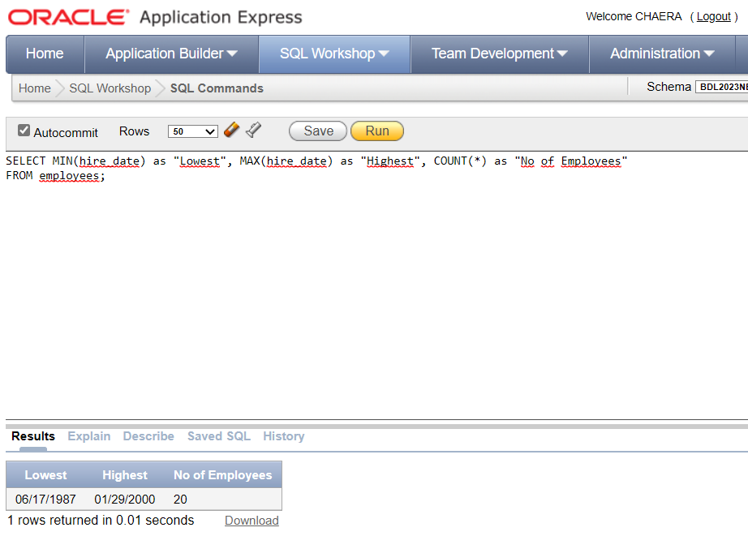

1. Create a list of department names and the departmental costs (salaries added up). Include only departments whose salary costs are between 15000 and 31000, and sort the listing by the cost.

→ SELECT d.department_name, SUM(e.salary) AS departmental_cost

FROM employees e

INNER JOIN departments d

ON e.department_id = d.department_id

GROUP BY d.department_name

HAVING SUM(e.salary) BETWEEN 15000 AND 31000

ORDER BY departmental_cost;

Result :

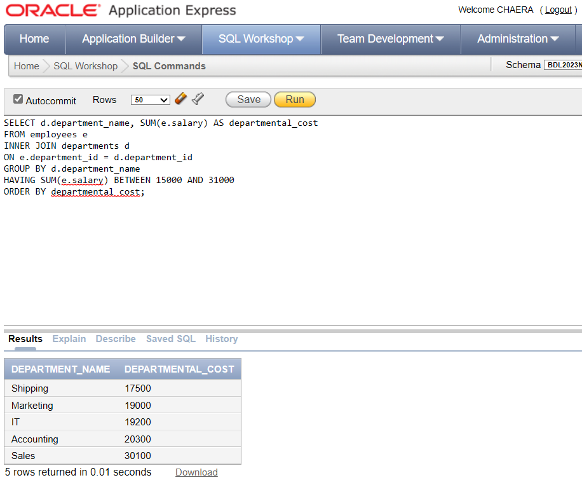

1. Create a list of department names, the manager id, manager name (employee last name) of that department, and the average salary in each department.

→ SELECT d.department_name, d.manager_id, e.last_name AS manager_name, AVG(e.salary) AS avg_salary

FROM employees e

INNER JOIN departments d

ON e.department_id = d.department_id

WHERE e.manager_id = d.manager_id

GROUP BY d.department_name, d.manager_id, e.last_name;

Result :

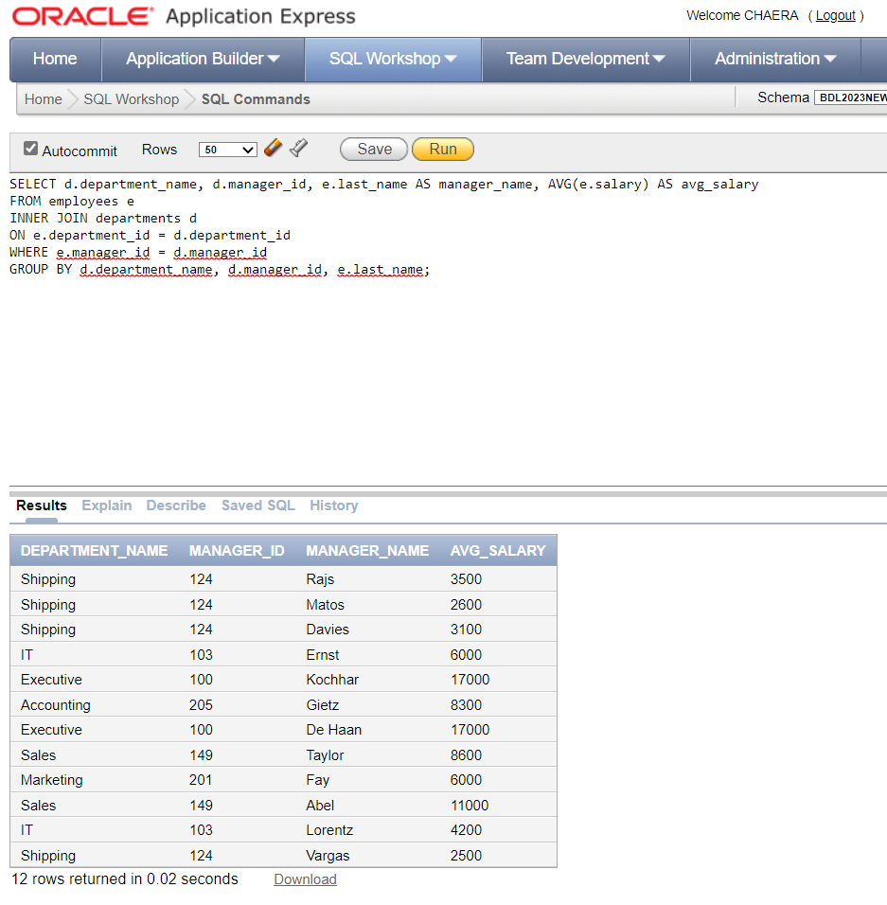

1. Show the highest average salary for the departments in the employees table. Round the result to the nearest whole number.

→ SELECT ROUND(AVG(salary)) as "Highest Avg Sal for Depts"

FROM employees

GROUP BY department_id

ORDER BY ROUND(AVG(salary)) DESC;

Result :

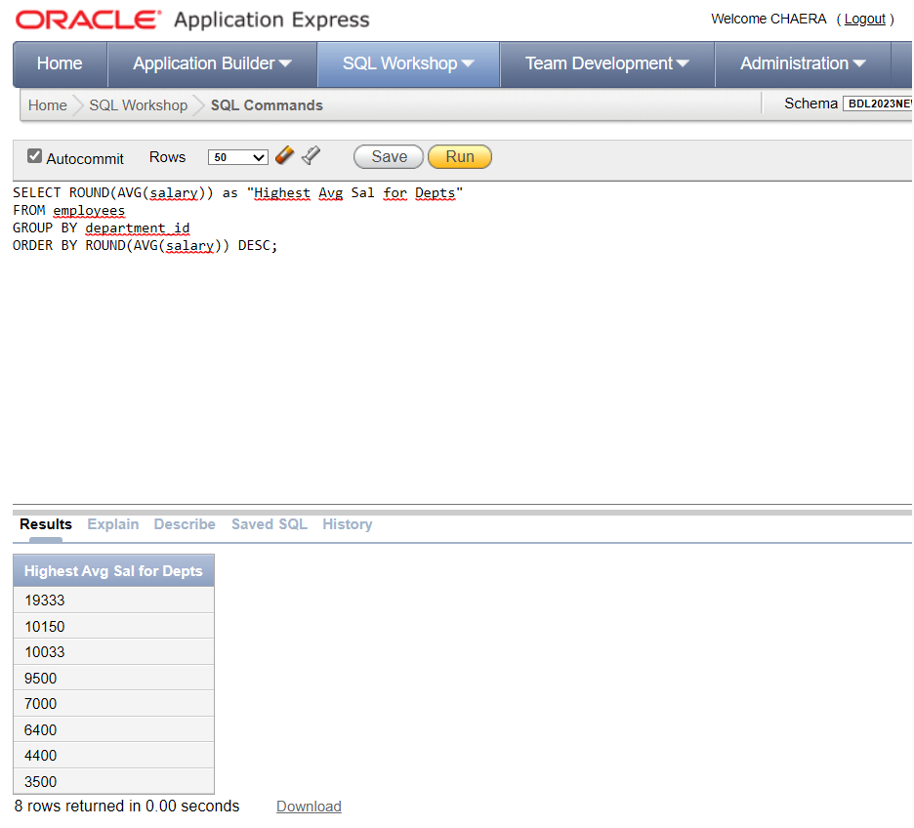

1. Create a list of department names and their monthly costs (salaries added up).

→ SELECT d.department_name as "Department Name",

SUM(e.salary) as "Monthly Cost"

FROM employees e

JOIN departments d

ON e.department_id = d.department_id

GROUP BY d.department_name;

Result :

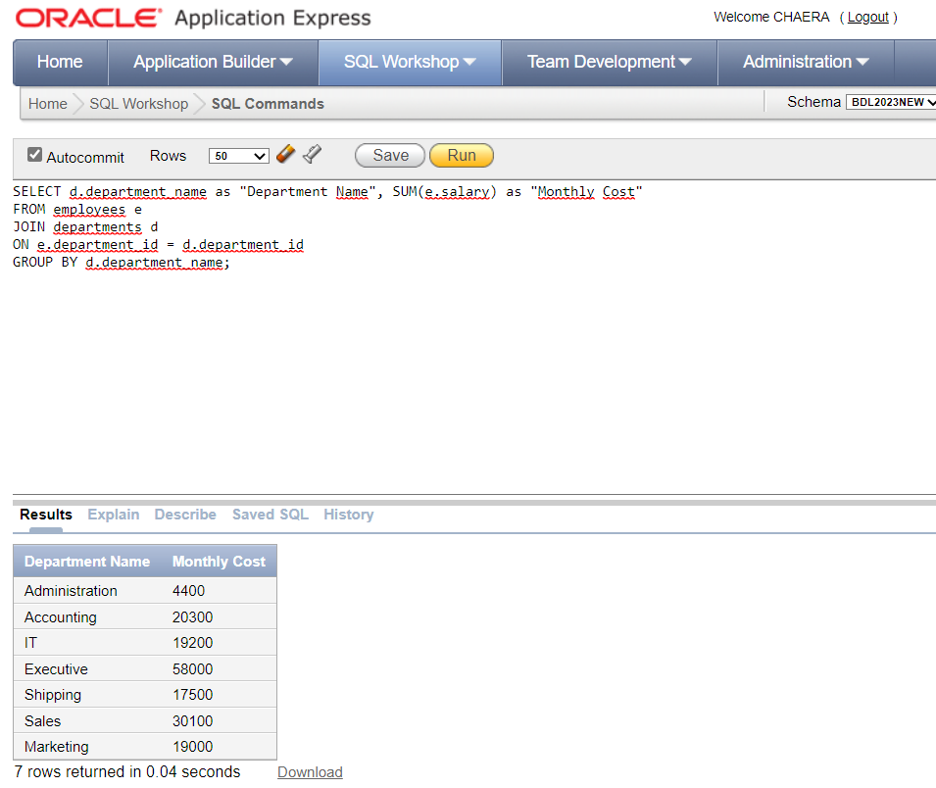

1. Create a list of department names, and job_ids. Calculate the monthly salary cost for each job_id within a department, for each department, and for all departments added together.

→ SELECT department_name as "Department Name",

job_id as "Job Title",

SUM(salary) as "Monthly Cost"

FROM employees e

JOIN departments d ON e.department_id = d.department_id

GROUP BY GROUPING SETS((department_name, job_id), (department_name))

ORDER BY department_name, job_id;

Result :

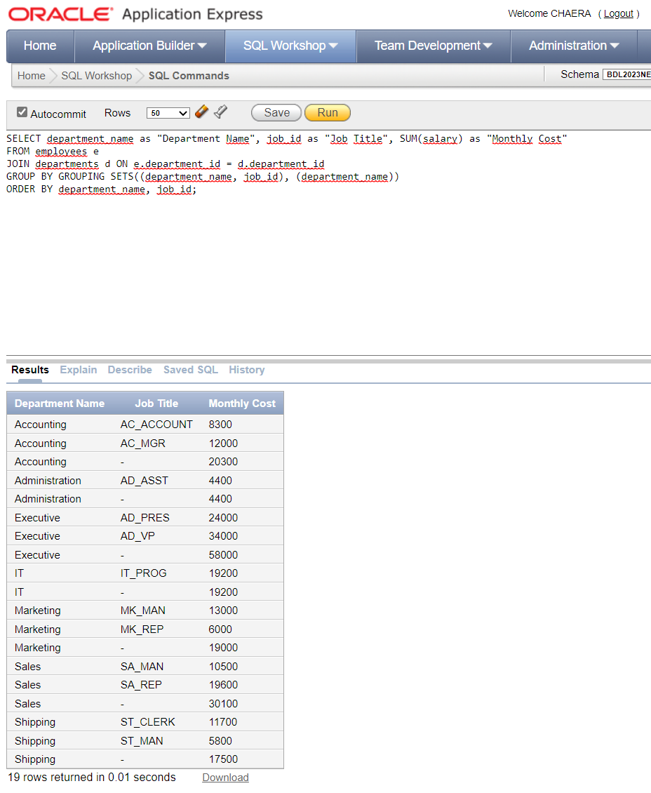

1. Create a list of department names, and job_ids. Calculate the monthly salary cost for each job_id within a department, for each department, for each group of job_ids irrespective of the department, and for all departments added together (Hint: Cube).

→ SELECT department_name as "Department Name",

job_id as "Job Title",

SUM(salary) as "Monthly Cost"

FROM employees e

JOIN departments d ON e.department_id = d.department_id

GROUP BY CUBE(department_name, job_id)

ORDER BY department_name, job_id;

Result :

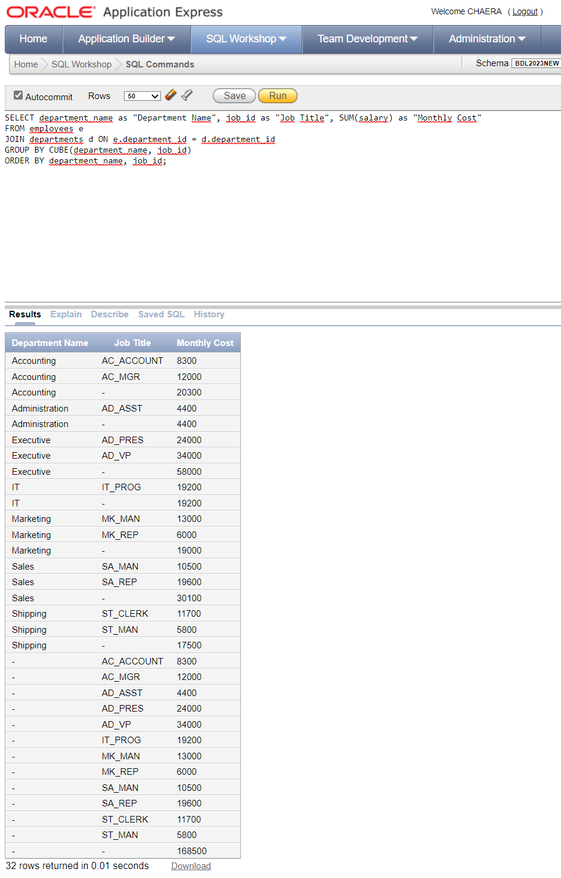

1. Expand the previous list to also show if the department_id or job_id was used to create the subtotals shown in the output (Hint: Cube, Grouping).

→ SELECT d.department_name as "Department Name", e.job_id as "Job Titlle", SUM(e.salary) as "Monthly Cost",

CASE WHEN GROUPING(d.department_id) = 1 THEN 'Yes' ELSE 'No' END AS department_id_used,

CASE WHEN GROUPING(e.job_id) = 1 THEN 'Yes' ELSE 'No' END AS job_id_used

FROM employees e

JOIN departments d ON e.department_id = d.department_id

GROUP BY CUBE(d.department_name, e.job_id, d.department_id, e.job_id)

ORDER BY d.department_name, e.job_id;

Result :

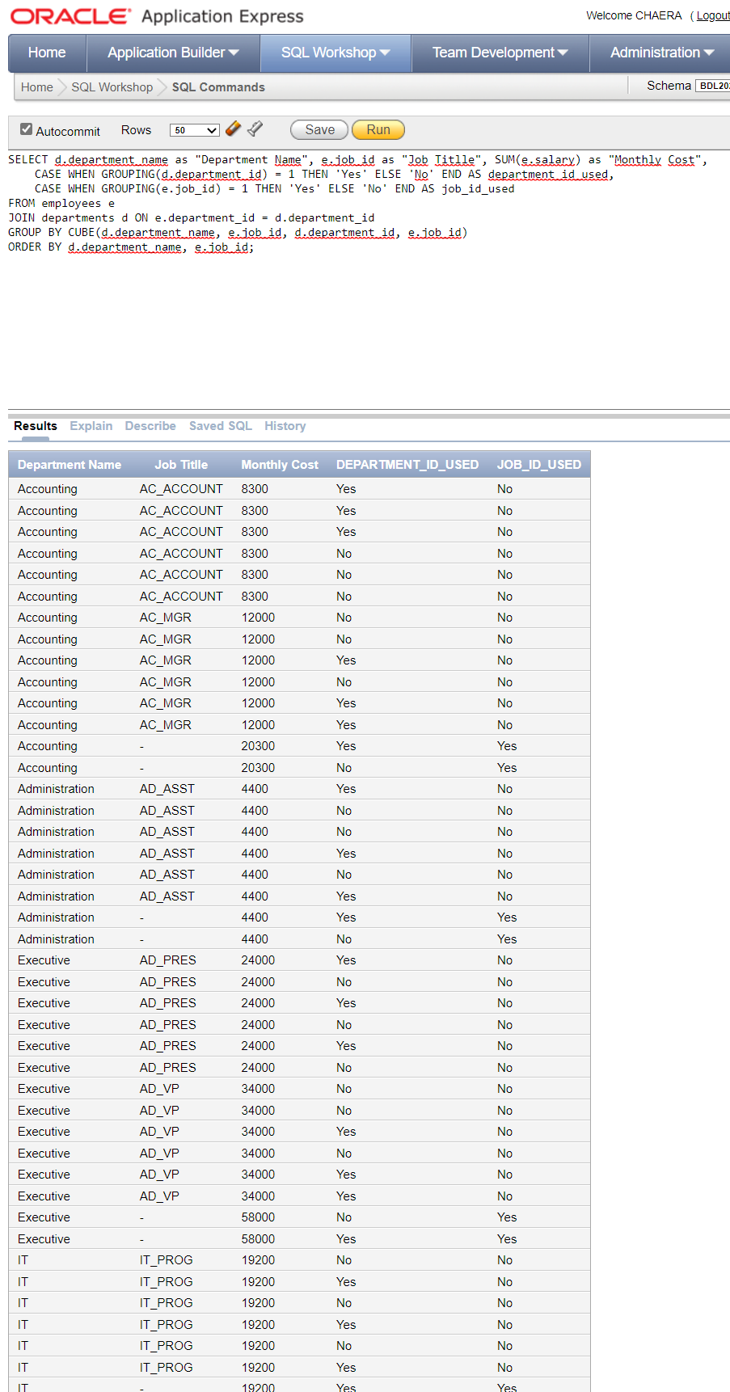

1. Create a list that includes the monthly salary costs for each job title within a department. In the same list, display the monthly salary cost per city. (Hint: Grouping Sets).

→ SELECT department_name, job_id, city, SUM(salary)

FROM employees e

JOIN departments d ON e.department_id = d.department_id

JOIN locations l ON d.location_id = l.location_id

GROUP BY GROUPING SETS((department_name, job_id), (city, job_id))

ORDER BY department_name, job_id, city;

Result :

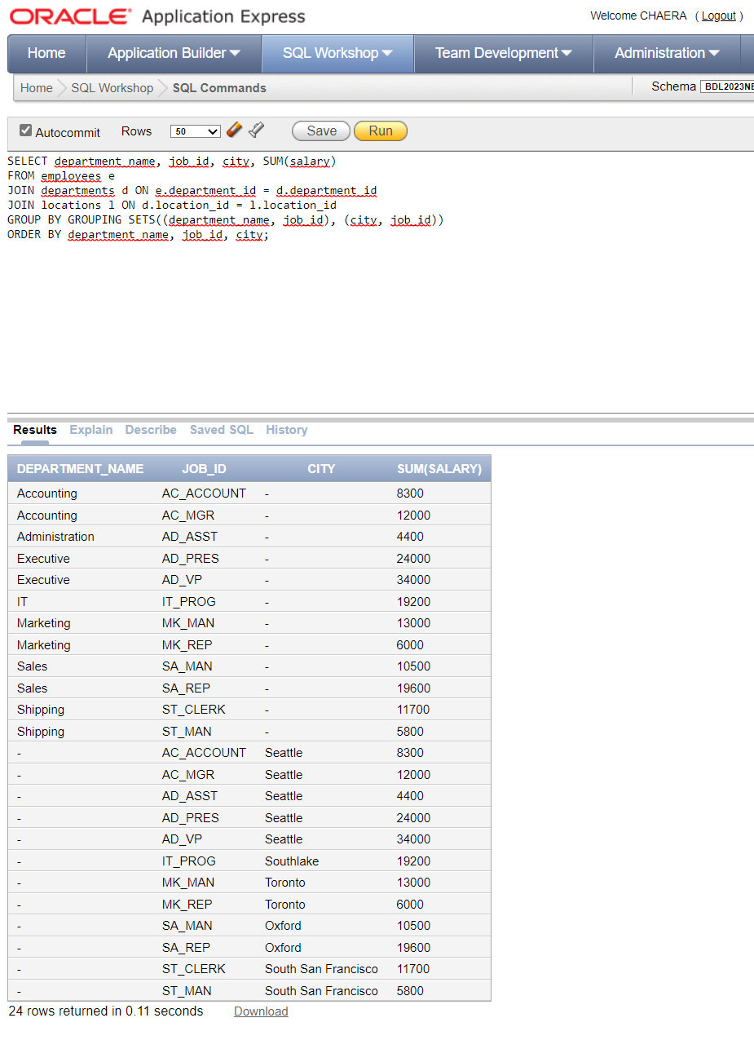

1. Create a list of employee names as shown and department ids. In the same report, list the department ids and department names. And finally, list the cities. The rows should not be joined, just listed in the same report. (Hint: Union).

→ SELECT employee_id as "Employee ID", first_name || ' ' || last_name as "Employee Name", e.department_id as "Department ID", NULL as "Department Name", NULL as "City"

FROM employees e

UNION

SELECT NULL AS employee_id, NULL AS employee_name, d.department_id, d.department_name, NULL AS city

FROM departments d

UNION

SELECT NULL AS employee_id, NULL AS employee_name, NULL AS department_id, NULL AS department_name, l.city

FROM locations l

ORDER BY 3, 1;

Result :

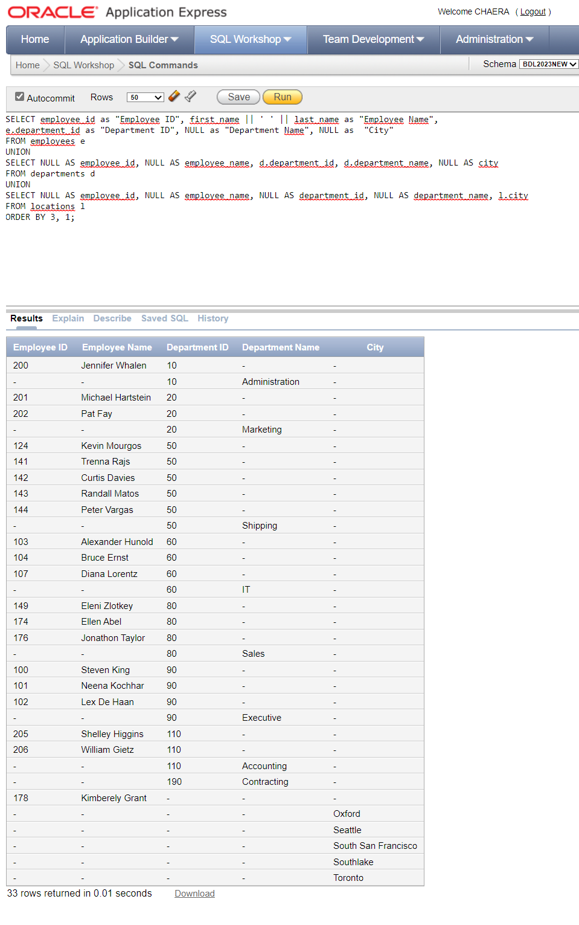

1. Create a list of each employee's first initial and last name, salary, and department name for each employee earning more than the average for his department.

→ SELECT SUBSTR(first_name,1,1)|| '.' ||last_name as "Employee", salary as "Salary", department_name as "Department Name"

FROM employees e

JOIN departments d ON e.department_id = d.department_id

WHERE e.salary > (SELECT AVG(salary) FROM employees WHERE department_id = e.department_id)

ORDER BY d.department_name, e.last_name;

Result :

